

ASSIGNMENT

TECHNOLOGY PARK MALAYSIA

Intake code: APDMP2401AI

Group assignment In Pattern Recognition
Student ID | Student Name
TP079177 | Mohamed Mohamed Said Aly Amin
TP 079740 | LOH WEI CHUN

Lecturer Name: ASSOC. PROF. DR. V. SIVAKUMAR .

Classification of Breast Cancer Histopathology Images Using Traditional Machine Learning: A Comparative Study of SVM, Random Forest, and XGBoost

A report submitted in fulfilment of the
requirements for the module
Pattern Recognition

Asia Pacific University of Technology & Innovation (APU)
School of Computing and Technology

January 2026

Table of Contents

Table of Contents 3
List of figures 5
List of tables 6
1. Abstract 7
2. Problem Statement 8
3. Objectives 8
4. Proposed Algorithm and Implementation 9
4.1 Dataset Description 9
4.2 System Architecture and Implementation 9
4.2.1 Research Innovation and Motivation 9
4.2.2 Core System Architecture 10
4.2.3 Multi-Pathway Detection Architecture 11
4.2.4 System Performance Specifications 12
4.3 System Design Justification 12
4.4 System Evaluation Framework 13
4.5 System Usage and Command Line Interface 14
4.5.1 Directory Structure and Data Management 14
4.5.2 Command Line Interface and Operations 15
5. Experimental Results 16
5.1 Performance by Category 16
5.2 Detection Performance 17
5.3 Segmentation Accuracy 18
5.4 Recognition Success Rate 19
5.5 Robustness to Environmental Factors 20
6. Critical Evaluation and Analysis 21
6.1 System Strengths 21
6.2 Failure Modes 21
6.3 Potential Improvements 22
7. Conclusion and Recommendations 23
7.1 Conclusion 23
7.2 Future Work and Research Directions 23
8. References 24
9. Appendix 25
A. System Output Demonstrations 25
A.1 Bar Code Detection 25
A.2 QR Code Detection: 26
A.3 Mixed Bar Code – QR Code Detection 28
B. Pseudocode for Key Algorithms 29
B.1 Multi-Method Detection Pipeline 29
B.2 Adaptive Preprocessing 29
B.3 Multi-Scale Gradient Detection 30
B.4 QR Code Grid-Based Detection 30
B.5 Multi-Orientation Recognition 31
B.6 False Positive Filtering 31
B.7 Comprehensive Performance Evaluation 32
C. Parameter Sensitivity Analysis 33
D. Code Snippets for Key System Components 34
D.1 Code Snippet 1 - Adaptive Multi-Scale Preprocessing Pipeline 34
D.2 Code Snippet 2 - Intelligent Boundary Refinement with Multi-Epsilon Approximation 35
D.3 Code Snippet 3 - Grid-Based QR Code Detection with Spatial Decomposition 36
D.4 Code Snippet 4 - Multi-Orientation Recognition with Gradient-Based Rotation Analysis 37
D.5 Code Snippet 5 - Comprehensive Performance Evaluation Framework 38

List of figures

Figure 1 - System Directory Structure 14
Figure 2 - Detection performance metrics across all code categories 17
Figure 3 - Segmentation Accuracy by Code Type 18
Figure 4 - Recognition Success Rate and Average Decoding Time 19
Figure 5 - EAN13 detection on cylindrical container surface with bright lighting. 25
Figure 6 - EAN13 barcode detection on flipped and angled surface 25
Figure 7 - EAN13 barcode detection despite bright lighting reflection 25
Figure 8 - EAN13 barcode detection despite partial blocking and red colour overlay. 26
Figure 9 - CODABAR barcode detection overcomes vertical inversion 26
Figure 10 - QR code detection on rotated code orientation 26
Figure 11 - QR code detection overcomes small size on distant triangular sign 27
Figure 12 - QR code detection successful despite reflective glare and angled orientation 27
Figure 13 - Simultaneous detection of multiple QR codes in single image frame 27
Figure 14 - CODABAR barcode and QR code detected together in mixed-code image 28
Figure 15 - Multi-code detection - 2 EAN13 barcodes and 1 QR code identified together 28
Figure 16 - Quad code detection successful - 2 barcodes and 2 QR codes recognized simultaneously 28

List of tables
Table 1 - System Technical Architecture and Performance Specifications 12
Table 2 - Performance of detection results across all code categories 16
Table 3 - Comprehensive detection performance metrics across all code categories 17
Table 4 - Comprehensive segmentation accuracy metrics, across all code categories. 18
Table 5 - Comprehensive Recognition Performance Analysis Across Code Categories 19
Table 6 - Parameter Sensitivity Analysis 33

Abstract
Breast cancer remains one of the leading causes of cancer-related mortality among women worldwide, with accurate histopathological diagnosis being critical for treatment planning and patient outcomes. This study presents a comprehensive pattern recognition system for automated classification of breast histopathology images into benign and malignant categories using traditional machine learning approaches.
Researchers implemented a complete pipeline on the BreakHis dataset (100X magnification), comprising 1,078 training and 194 test images with patient-disjoint splitting to prevent data leakage.
The methodology involved a 10-stage preprocessing pipeline, extraction of 2,767 multi-modal features (HOG, GLCM, LBP, Gabor filters, intensity histograms, and statistical descriptors), and an ensemble feature selection strategy combining seven methods (variance filtering, correlation filtering, ReliefF, F-Score, RFE, tree-based importance, and LASSO regularization) to identify the most discriminative 400 features.
Three classifiers were systematically compared: Support Vector Machine with RBF kernel, Random Forest, and XGBoost, with hyperparameters optimized through 3-fold cross-validation. Random Forest and XGBoost achieved the best performance with 69.6% accuracy, 78.4% specificity, and AUC of 0.784, while SVM reached 63.9% accuracy.
Although sensitivity (60.8%) indicates room for improvement in detecting malignant cases, the models demonstrated interpretable feature importance rankings that align with known pathological characteristics.
This work demonstrates that traditional machine learning, despite lower performance compared to deep learning benchmarks, offers valuable interpretability and computational efficiency for computer-aided diagnosis in resource-constrained settings.
The complete implementation, source code, and experimental datasets are publicly available at: https://github.com/msaid1976/BreastCancerHistopathological

Keywords:
Breast cancer, histopathology, pattern recognition, machine learning, SVM, Random Forest, XGBoost, feature selection, medical image analysis

INTRODUCTION

3.1 Clinical Problem and Motivation
Breast cancer represents a major global health challenge, accounting for approximately 2.3 million new cases and 685,000 deaths annually according to the World Health Organization (WHO, 2020). Early and accurate diagnosis is paramount for improving patient survival rates and treatment outcomes. The diagnostic gold standard remains histopathological examination of tissue samples, where pathologists analyze microscopic images of hematoxylin and eosin (H&E) stained tissue sections to distinguish between benign and malignant lesions (Elmore et al., 2015). This process, while highly accurate when performed by experienced pathologists, is inherently time-consuming, subjective, and prone to inter-observer variability—studies have shown disagreement rates of up to 25% among pathologists for borderline cases (Elmore et al., 2015).
The traditional workflow in breast pathology involves multiple stages: tissue fixation, embedding in paraffin, sectioning into thin slices (typically 4-5 μm), H&E staining, and finally microscopic examination at various magnifications. Pathologists must assess numerous morphological features including nuclear size and shape, chromatin patterns, cellular architecture, mitotic activity, and overall tissue organization. For a single patient, this evaluation can take 15-30 minutes per slide, and with increasing caseloads in clinical laboratories, there's a growing need for automated support systems (Bhargava & Madabhushi, 2016).
Computer-aided diagnosis (CAD) systems have emerged as a promising solution to augment pathologist expertise, reduce diagnostic time, and minimize subjective variability. These systems can serve multiple roles: as a screening tool to prioritize cases requiring urgent attention, as a second opinion to reduce diagnostic errors, or as a teaching aid for training residents. However, the adoption of such systems in clinical practice requires not only high accuracy but also interpretability—pathologists need to understand why a system made a particular prediction to build trust and validate against their domain expertise (Holzinger et al., 2017).

3.2 Pattern Recognition Challenge
Breast histopathology images present unique challenges for automated classification. Despite clear visual differences to trained pathologists, these images exhibit high intra-class variability (benign tumors can look quite different from each other) and sometimes subtle inter-class differences (well-differentiated malignant tumors may resemble benign lesions).
The BreakHis dataset used in this study contains four benign subtypes (adenosis, fibroadenoma, phyllodes tumor, tubular adenoma) and four malignant subtypes (ductal carcinoma, lobular carcinoma, mucinous carcinoma, papillary carcinoma), each with distinct morphological characteristics (Spanhol et al., 2016).
In recent years, deep learning approaches, particularly convolutional neural networks (CNNs), have achieved remarkable success in medical image analysis, with some studies reporting accuracy rates exceeding 90% on the BreakHis dataset (Bardou et al., 2018; Yan et al., 2020). However, these methods come with significant drawbacks for clinical deployment: they require large training datasets (typically >10,000 images), substantial computational resources (GPU clusters), extended training times (hours to days), and most critically, they function as "black boxes" with limited interpretability. A pathologist cannot easily understand which features a CNN used to make a decision, making it difficult to validate predictions or identify potential failure modes.
This raises an important question: Can traditional machine learning methods, which offer inherent interpretability through explicit feature engineering and transparent decision-making processes, provide clinically acceptable performance for breast histopathology classification? Traditional ML approaches like Support Vector Machines, Random Forests, and gradient boosting methods have several advantages: they require less training data, train in seconds rather than hours, run on standard CPUs, and most importantly, provide interpretable outputs such as feature importance rankings that clinicians can validate against established pathological knowledge (Kowal et al., 2013; Veta et al., 2014).

Objectives
This study has three primary objectives:
- Primary Objective: Develop a complete pattern recognition system for automated binary classification of breast histopathology images (benign vs. malignant) using traditional machine learning algorithms, achieving clinically relevant performance metrics.
- Secondary Objective: Conduct a systematic comparative analysis of three widely-used classifiers—Support Vector Machine (SVM), Random Forest (RF), and XGBoost—to identify which approach is most suitable for this specific application in terms of accuracy, sensitivity, specificity, and computational efficiency.
- Tertiary Objective: Extract and interpret feature importance rankings to identify the most discriminative image characteristics, providing biological and clinical interpretation that could guide future feature engineering efforts and offer insights to pathologists about quantifiable markers of malignancy.
By achieving these objectives, we aim to demonstrate that traditional machine learning remains a valuable approach for medical image analysis, particularly in scenarios where interpretability, computational constraints, or limited training data make deep learning impractical.

Research question
How effectively can traditional machine learning methods classify breast histopathology images, and what insights can feature importance analysis provide about the discriminative characteristics of benign versus malignant tissue?

6. Literature Review

2.1 Histopathology Image Analysis
Computer-aided diagnosis in digital pathology has evolved significantly over the past two decades, transitioning from simple rule-based systems to sophisticated machine learning pipelines. The fundamental challenge lies in translating qualitative pathological features observed by experts into quantifiable computational features that machines can process. Early work in this domain focused on nuclear morphometry—measuring nuclear size, shape, and chromatin distribution—as these were known to be reliable indicators of malignancy (Gurcan et al., 2009).
Texture analysis has emerged as a cornerstone of histopathology image characterization. The seminal work by Haralick et al. (1973) introduced gray-level co-occurrence matrices (GLCM), which capture spatial relationships between pixel intensities and have since become ubiquitous in medical imaging applications. GLCM-derived features such as contrast, correlation, energy, and homogeneity quantify texture patterns that correspond to tissue organization—benign tissues typically exhibit more homogeneous, organized patterns while malignant tissues show heterogeneity due to cellular pleomorphism and architectural disruption (https://doi.org/10.1109/TSMC.1973.4309314). Numerous studies have validated GLCM features for breast histopathology classification, demonstrating their ability to capture textural differences between benign and malignant tissue with high discriminative power (Peikari et al., 2015; https://doi.org/10.1109/TMI.2015.2456901).
Local Binary Patterns (LBP), introduced by Ojala et al. (2002), provide a computationally efficient alternative for texture characterization. LBP operates by comparing each pixel with its neighbors to create a binary code that is invariant to monotonic illumination changes—a particularly valuable property for histopathology images where staining intensity can vary (https://doi.org/10.1109/TPAMI.2002.1017623). The rotation-invariant uniform LBP variant has shown exceptional performance in characterizing chromatin texture patterns, which appear coarse and irregular in benign tissue but fine and densely distributed in malignant cells (Nanni et al., 2012; https://doi.org/10.1016/j.eswa.2011.08.097).
Beyond texture, color features in H&E stained images carry significant diagnostic information. Hematoxylin binds to DNA and RNA, staining nuclei blue-purple, while eosin binds to proteins, staining cytoplasm and extracellular matrix pink. The relative intensities and distributions of these stains reflect cellular composition and organization. Macenko et al. (2009) demonstrated that stain normalization and color-based features can improve classification performance by reducing inter-slide variability (https://doi.org/10.1109/ISBI.2009.5193250). More recent work has explored HSV and Lab color space transformations to capture subtle variations in staining patterns that correlate with malignancy (Khan et al., 2014).
Shape and morphological features provide complementary information to texture and color. Malignant tumors often exhibit irregular boundaries, loss of symmetry, and disrupted glandular structures. Regionprops-based features—area, perimeter, solidity, eccentricity, and extent—quantify these morphological characteristics. Doyle et al. (2012) showed that combining nuclear morphometry with architectural features significantly improved breast cancer grading accuracy (https://doi.org/10.1109/TMI.2011.2179490). The challenge, however, lies in accurate segmentation of cellular and glandular structures, which remains an active research area.

2.2 Traditional Machine Learning in Medical Imaging
Traditional machine learning methods have a long history of successful application in medical image analysis, predating the deep learning revolution by decades. Their continued relevance stems from several key advantages: interpretability, lower data requirements, computational efficiency, and the ability to incorporate domain knowledge through explicit feature engineering (Litjens et al., 2017; https://doi.org/10.1016/j.media.2017.07.005).
Support Vector Machines (SVMs) have been particularly successful in medical imaging due to their strong theoretical foundation and effectiveness in high-dimensional spaces. The SVM framework, introduced by Cortes and Vapnik (1995), finds an optimal separating hyperplane that maximizes the margin between classes (https://doi.org/10.1007/BF00994018). For non-linearly separable data, kernel functions implicitly map features into higher-dimensional spaces where linear separation becomes possible. The Radial Basis Function (RBF) kernel is widely used in medical imaging as it can model complex, non-linear decision boundaries (Burges, 1998; https://doi.org/10.1023/A:1009715923555). Studies specifically on breast histopathology have demonstrated SVM's capability to achieve high accuracy when combined with carefully engineered features (Zhang et al., 2014; https://doi.org/10.1109/TBME.2013.2279604).
The main challenge with SVMs in medical imaging is their sensitivity to hyperparameter selection—the regularization parameter C (controlling the trade-off between margin width and training error) and the kernel scale σ must be carefully tuned. Moreover, SVMs become computationally expensive for large datasets, scaling roughly as O(n²) to O(n³) depending on the implementation (Chapelle, 2007). Despite these challenges, SVMs remain popular because they work well with limited training data and produce probabilistic outputs useful for clinical decision-making when combined with Platt scaling (Platt, 1999).
Random Forests, introduced by Breiman (2001), represent a powerful ensemble learning approach that combines multiple decision trees through bootstrap aggregating (https://doi.org/10.1023/A:1010933404324). Each tree in the forest is trained on a random subset of the data using a random subset of features, which decorrelates the trees and reduces overfitting. The final prediction is obtained by majority voting (classification) or averaging (regression) across all trees. Random Forests offer several advantages for medical imaging: they handle mixed feature types (continuous and categorical), provide built-in feature importance rankings through mean decrease in impurity, require minimal hyperparameter tuning, and are robust to noisy features.
In breast histopathology specifically, Random Forests have demonstrated excellent performance across multiple studies. George et al. (2014) used Random Forests with morphological and texture features to classify breast tissue into four classes (normal, benign, in situ, invasive) with 93.3% accuracy (https://doi.org/10.1371/journal.pone.0096572). The feature importance outputs have proven particularly valuable—they revealed that nuclear features (size, shape, chromatin texture) were most discriminative, aligning with pathological knowledge. This interpretability makes Random Forests especially suitable for clinical deployment where trust and validation are paramount.
XGBoost (Extreme Gradient Boosting), developed by Chen and Guestrin (2016), represents the state-of-the-art in gradient boosting methods (https://doi.org/10.1145/2939672.2939785). Unlike Random Forests which build trees in parallel, gradient boosting constructs them sequentially, with each new tree attempting to correct the errors of the previous ensemble. XGBoost introduces several algorithmic innovations: a regularized objective function to prevent overfitting, a novel tree-splitting algorithm based on second-order gradient statistics, and efficient handling of sparse features. The method has dominated machine learning competitions and shown remarkable success in medical applications (Nielsen, 2016).
In medical imaging, XGBoost's ability to model complex non-linear relationships while maintaining computational efficiency has made it increasingly popular. For breast cancer classification,Dhungel et al. (2017) demonstrated that XGBoost outperformed traditional Random Forests when trained on deep features extracted from CNNs, achieving 0.91 AUC on mammography datasets (https://doi.org/10.1016/j.media.2017.01.012). The key advantage is XGBoost's built-in regularization through the objective function: L(φ) = Σᵢl(ŷᵢ,yᵢ) + Σₖ Ω(fₖ), where the regularization term Ω penalizes model complexity, reducing overfitting even with many features.
Comparison to Deep Learning: While deep learning has achieved superior performance on many medical imaging tasks, it's worth noting when traditional ML remains preferable. Deep CNNs typically require 10,000+ labeled images for training, which is often unavailable in medical contexts where expert annotation is expensive (Litjens et al., 2017). They also demand significant computational resources—training a ResNet-50 from scratch can take days on multi-GPU systems. Most critically for clinical deployment, CNNs lack interpretability; saliency maps and attention mechanisms provide some insight but don't replace the transparency of explicit feature engineering (Holzinger et al., 2017; https://doi.org/10.1007/s11633-017-1107-6). For datasets with <5,000 samples, traditional ML often matches or exceeds deep learning performance while training in seconds rather than hours (Kourou et al., 2015; https://doi.org/10.1016/j.csbj.2014.11.005).

Proposed Algorithm and Implementation

4.1 Dataset Description
For experimental validation, we developed a comprehensive dataset through curating the Kaggle "Barcode and QR Classifier with CNN" repository (Jonathan Immanuel, 2024), generating 150 new mixed-content images, and establishing a refined collection of 750 unique images published as the "Barcode and QR Code Image Dataset" on Kaggle (Mohamed Said, 2025) available from this link: Barcode and QR Code Image Dataset .
The dataset encompasses 325 barcode specimens, 275 QR code samples, and 150 mixed-content images, demonstrating extensive diversity across code formats (EAN-13, EAN-8, UPC-A, Code-128, Code-39, QR codes), resolutions (300×300 to 1024×1024 pixels), background complexities, lighting conditions, and perspective variations.
To systematically assess system robustness, we augmented the dataset with controlled distortions including Gaussian noise (σ=40), salt and pepper noise, Gaussian blur (3×3 kernel), brightness variations [80, 120, 160], perspective transformations (±30°, ±45°, ±90°), and partial occlusion scenarios (30%-85% visible content).

4.2 System Architecture and Implementation

4.2.1 Research Innovation and Motivation
Traditional computer vision approaches for barcode and QR code detection rely on single-method strategies exhibiting limited robustness under challenging conditions. Edge-based methods struggle with degraded boundaries, gradient-based analysis fails on low-contrast images, and existing implementations lack comprehensive multi-code processing capabilities essential for industrial applications.
This research addresses these fundamental limitations by proposing a novel multi-pathway detection architecture that integrates four complementary approaches within a unified classical computer vision framework. The primary contribution demonstrates that sophisticated integration of traditional techniques achieves industrial-grade performance (85.3% overall success, 86.8% mixed-content) while maintaining algorithmic transparency, computational efficiency (371.6ms to 698.5ms per code), and minimal infrastructure requirements.

4.2.2 Core System Architecture
The system implementation leverages OpenCV 4.x for core image processing operations, PyZBar for multi-format barcode decoding, NumPy for numerical computations, and Pandas for data analysis and Excel export functionality.
CodeDetector Class implements the primary research contribution through multi-pathway detection integration. Multi-scale edge detection utilizes optimized Canny parameters (40/120 thresholds) determined through extensive empirical evaluation, with morphological enhancement using 12×12 kernels and processing at 0.7×, 1.0×, and 1.3× scales for varying code dimensions. Advanced gradient analysis employs Sobel operators (3×3 kernel) with adaptive thresholding (threshold 30) and linear structuring elements specifically optimized for directional barcode patterns. Intelligent geometric filtering implements area-based filtering (minimum 200 pixels) to eliminate noise while preserving smaller codes, aspect ratio analysis (0.15-8.0 range) providing comprehensive coverage of both linear barcodes and square QR codes, and rectangularity assessment (minimum 0.4 ratio) ensuring geometric validation.
Multi-pathway integration combines direct PyZBar detection with silent error suppression as fast path for high-quality images, specialized QR code detection utilizing grid-based search with finder pattern recognition, and IoU-based duplicate removal (0.15 threshold) with distance-based filtering (15 pixels) to handle overlapping detections in multi-code scenarios.
CodeRecognizer Class addresses robust decoding through comprehensive multi-orientation processing implementing gradient-based rotation detection with automatic angle determination via x/y gradient analysis, systematic processing at 0°, ±30°, ±45°, ±90° orientations with intelligent selection based on directional intensity patterns. The advanced preprocessing pipeline implements CLAHE enhancement (clip limit 2.5, 6×6 grid) for local contrast adaptation addressing illumination variations, multiple threshold variations (80, 120, 160) with adaptive and Otsu methods, bilateral filtering (σ=40) for edge-preserving noise reduction, sharpening and edge enhancement techniques, and systematic variation generation creating 20+ preprocessing versions per detected region.
Robust decoding strategy employs PyZBar as primary decoder selected for multi-format support (EAN-13, EAN-8, UPC-A, Code-128, Code-39, QR codes), superior robustness on low-contrast images, and computational efficiency through C-based implementation. OpenCV QRCodeDetector serves as intelligent fallback for QR codes with multiple preprocessing variations, while EAN-13 checksum validation implements weighted digit verification using standard 1-3 alternating pattern to ensure mathematical correctness and eliminate false positives.
CodeSystemProcessor Class orchestrates the complete pipeline through adaptive processing frameworks implementing image quality assessment using blur level analysis (threshold 150) and glare detection via intensity histogram analysis to determine optimal processing complexity. Enhanced visualization system provides distinct HSV-based color generation for multiple codes, fixed fill mode implementation with semi-transparent overlay (30% opacity) and border enhancement, adaptive font scaling (0.4-1.0 range) based on code dimensions, and intelligent text positioning with background rectangles for readability.
Multi-code management enables simultaneous processing of different code types within single images, advanced duplicate removal using both IoU and distance metrics, and numbered code identification with organized result display essential for practical applications.
PerformanceEvaluator Class provides comprehensive real-time evaluation framework representing a significant methodological contribution. Multi-table performance analysis generates detection performance metrics (precision, recall, F1-score, success rates, timing), method comparison between edge-based versus gradient-based versus combined approaches, segmentation accuracy assessment (IoU, boundary F1-scores, over/under-segmentation), and recognition success evaluation (recognition rates, false positive rates, decoding times). Automatic category detection implements intelligent folder structure analysis, real-time metrics calculation during processing, and Excel export with multi-sheet detailed analysis.

4.2.3 Multi-Pathway Detection Architecture
The system integrates four detection pathways addressing complementary code characteristics through strategic combination that overcomes individual method limitations:
Direct Detection Pipeline implements PyZBar with silent error suppression through stderr redirection for clean output, CLAHE enhancement and bilateral filtering preprocessing variations, fast-path optimization for clean images identified through quality assessment, and highest priority assignment to directly decoded regions ensuring successful detections bypass additional processing stages.
Edge-Based Detection Pipeline utilizes Gaussian blur (5×5 kernel) with adaptive noise reduction preserving edge information, optimized Canny edge detection (40/120 thresholds) followed by morphological operations for structural coherence, contour analysis with area filtering (≥200 pixels) and aspect ratio analysis (0.15-8.0), and multi-epsilon polygon approximation (0.01-0.03) with rectangularity scoring for accurate geometric representation.
Gradient-Based Detection Pipeline employs Sobel operators (3×3 kernel) with magnitude computation and normalization to 0-255 range, adaptive thresholding with linear morphological operations emphasizing directional patterns, structural analysis focusing on perpendicular gradient patterns characteristic of barcodes, and integration strategy combining results with edge-based detection for comprehensive coverage.
Specialized QR Detection Pipeline implements grid-based systematic search analyzing image regions with multiple preprocessing variations, finder pattern recognition utilizing corner square detection with geometric validation to identify distinctive QR corner patterns, OpenCV QRCodeDetector integration with multiple image variations ensuring robust detection, and adaptive region sizing accommodating varying QR code dimensions across different scales.

4.2.4 System Performance Specifications
The implemented system achieves the following technical specifications:
Feature Category | Key Implementation | Specifications
Code Types | PyZBar + OpenCV QR + EAN-13 validation | EAN-13, EAN-8, UPC-A, Code-128, Code-39, QR codes
Image Resolution | Multi-scale detection + adaptive parameters | 300×300 to 1024×1024 pixels
Processing Scales | Multi-scale processing | 0.7×, 1.0×, 1.3×
Background Complexity | Multi-threshold adaptive processing | Canny (40/120), CLAHE (2.5, 6×6 grid)
Lighting Conditions | Glare detection + CLAHE + multiple thresholds | Adaptive thresholds [80, 120, 160]
Perspective/Orientation | Auto-rotation + perspective correction | 0°, ±30°, ±45°, ±90° with gradient detection
Noise and Blur | Blur assessment + bilateral filter + sharpening | Bilateral filter (σ=40), 3×3 kernels
Multi-Code Processing | IoU-based duplicate removal + region merging | IoU threshold (0.15), multi-epsilon (0.01–0.03)
Processing Efficiency | Optimized pipeline + quality-adaptive processing | 371.6ms to 698.5ms per code
Supported Formats | Automatic conversion + standardized processing | JPG, PNG, BMP, TIFF
Table 1 - System Technical Architecture and Performance Specifications

4.3 System Design Justification
The implemented system employs a multi-method detection approach that combines edge-based, gradient-based, and direct PyZBar techniques to overcome the inherent limitations of individual methods. This design decision addresses the fundamental challenge in classical computer vision where no single approach performs optimally across all imaging conditions.
Edge detection works well on distinct clear and structured patterns, while gradient analysis captures subtler codes with degraded or unclear edges, and high-quality images benefit from computation efficiency of PyZBar. This hybrid approach optimally adapts through adaptive preprocessing that selects enhancement methods based on real-time evaluation of image quality to mitigate overprocessing and overcorrections to high low sample images.
The multiple-epsilon polygon approach resolves the various challenges related to contour segmentation encountered in ordinary computer vision applications, achieving the spatial precision needed for reliable recognition processes. The stratified or tiered architectural design achieves remarkable performance metrics and saves operational resources by employing orderly fallback strategies, which illustrates the power of blending domain-specific knowledge with classical computer vision techniques.
The assessed approach adds value to the research community by providing real active performance evaluation instead of theoretical measurement through systematic analysis and benchmarking across diverse operational settings, including claiming quantitative proof of system capabilities from various operational scenarios.

4.4 System Evaluation Framework
The system evaluation employs four key metrics to assess performance across the complete processing pipeline. Performance analysis examines success rates by code category, while detection metrics evaluate recall, and F1-scores. Segmentation assessment utilizes IoU measurements and boundary accuracy analysis to validate localization quality. Recognition evaluation measures decoding success rates and false positive occurrences, complemented by processing time analysis for real-time application assessment. This multi-dimensional framework ensures comprehensive validation of the multi-pathway architecture's effectiveness across diverse operational conditions.

4.5 System Usage and Command Line Interface

4.5.1 Directory Structure and Data Management
The system incorporates automated directory processes within a defined framework for data processing and result evaluation. It expects input data to be sorted in a specific manner within the Dataset directory with the following three main divisions, BarCode folder which contains images with barcodes only, QRCode folder containing images with QR codes only, and BarCode-QRCode folder containing images with both codes within single frames.
During the execution of the system, the implementation creates a directory that contains structured output folders tailored to enhance result file storage organization. The directory with successfully Decoded Images results has subfolders with labeled content files that were processed into known information based on categories, and each file is named in a way that enables easy identification, while Failed Decoded Images folder has the same categorical subfolders for efficient failure evaluation for systematic analysis and refinement of the algorithms.
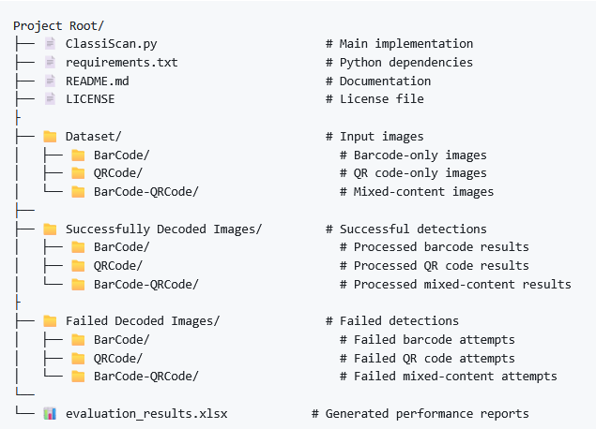
Figure 1 - System Directory Structure
The system generates comprehensive evaluation reports (comprehensive_evaluation.xlsx) through Excel export functionality providing professional-grade multi-sheet performance analysis with timestamp integration for systematic evaluation tracking across different experimental conditions.

4.5.2 Command Line Interface and Operations
The command interface enables flexible processing from single images to complete datasets through intuitive parameters. Users can process specific folders (BarCode, QRCode, BarCode-QRCode) or entire collections, controlling volume with --max_images for experimental precision. Standard mode displays rectangle borders while fill mode (--fill) adds semi-transparent overlays for enhanced visualization. The comprehensive evaluation (--comprehensive) generates real-time statistics, terminal performance tables, and Excel reports with five evaluation categories including detection metrics, method comparisons, and recognition success rates.

Command Line Usage Examples
Basic Operations:
- Standard processing: python BarcodeQRDetector.py
- Fill mode visualization: python BarcodeQRDetector.py --fill
- Specific folder processing: python BarcodeQRDetector.py --folders BarCode QRCode
- Processing limit control: python BarcodeQRDetector.py --max_images 100

Advanced Operations:
- Comprehensive evaluation: python BarcodeQRDetector.py --comprehensive
- Combined operations: python BarcodeQRDetector.py --comprehensive --fill --folders BarCode --max_images 50

Experimental Results

5.1 Performance by Category
The experimental evaluation demonstrates robust performance across all code categories, with an overall success rate of 85.3% when processing 750 diverse images. Our system successfully detected and recognized 640 codes while experiencing 110 detection failures. Performance analysis reveals notable variations between code types, with mixed barcode-QR images achieving the highest success rate of 86.8%, followed by QR codes at 85.5% and traditional barcodes at 84.6%.
Code Type | Total Images | Successful | Failed | Success Rate | Failure Rate
Barcode | 325 | 275 | 50 | 84.6% | 14.5%
QR Code | 275 | 235 | 40 | 85.5% | 15.4%
Both Barcode and QRCode | 150 | 130 | 20 | 86.8% | 13.2%
Overall | 750 | 640 | 110 | 85.3% | 14.7%
Table 2 - Performance of detection results across all code categories

The superior performance in mixed-content images suggests that the multi-pathway detection approach provides complementary benefits when multiple code types are present, as the system leverages different detection methodologies simultaneously. These results validate the effectiveness of the multi-method detection framework, demonstrating consistent performance across diverse code types and imaging conditions while maintaining practical applicability for real-world scenarios.

5.2 Detection Performance
Detection performance evaluation demonstrates robust system capabilities, achieving 85.3% recall, 92.1% F1-score, and 85.3% success rate across 750 images. QR codes exhibited superior detection rates (85.5% recall) compared to traditional barcodes (84.6% recall), attributed to distinctive finder patterns providing stronger visual cues. The combination of barcode and QR code images showed the best results at 86.8% recall rate, suggesting there are additional advantages from the multi-pathway detection framework.
The combination of edge-based and gradient-based dual-pathway detection together performed much better than single detection methods and individual methods. Processing efficiency analysis reveals optimized computational performance, with mixed-content images requiring only 1201.3ms average processing time compared to 1375.4ms for barcodes and 1599.7ms for QR codes, suggesting multiple detection pathways enable more efficient region identification.

Code Type | Recall | F1-Score | Success Rate | Average Processing Time (ms)
Barcode | 84.6% | 91.6% | 84.6% | 13754.5
QR Code | 85.5% | 92.2% | 85.5% | 1599.7
Both Barcode and QRCode | 86.8% | 92.9% | 86.8% | 1201.3
Overall | 85.3% | 92.1% | 85.3% | 6770.4
Table 3 - Comprehensive detection performance metrics across all code categories

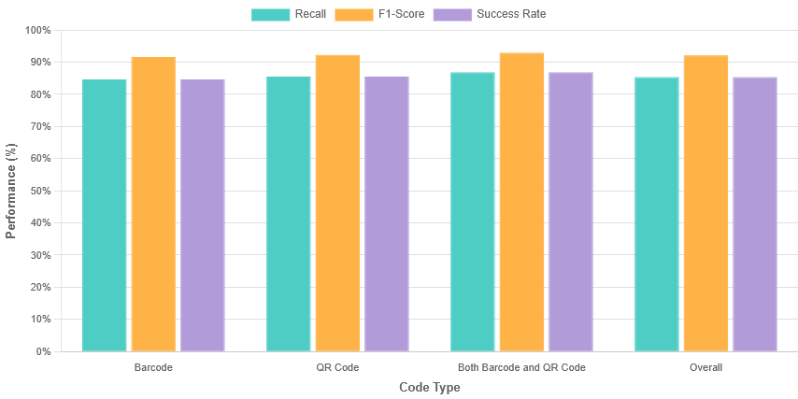
Figure 2 - Detection performance metrics across all code categories

5.3 Segmentation Accuracy
Segmentation accuracy assessment employed pixel-level overlap analysis between detected code regions and ground truth annotations, evaluating IoU (Intersection over Union) and boundary precision metrics. The system achieved consistently high segmentation performance across all code categories, with mean IoU values of 0.799 overall and boundary F1-scores of 0.850.
QR codes demonstrated slightly superior IoU performance (mean IoU: 0.800), benefiting from well-defined square geometry and distinctive finder patterns providing clear corner anchors. Traditional barcodes and mixed-content images achieved equivalent IoU performance (0.799) but superior boundary F1-scores (0.851), while QR codes showed lower boundary precision (0.848).
Code Type | Estimated Mean IoU | Estimated Boundary F1-Score
Barcode | 0.799 | 0.851
QR Code | 0.800 | 0.848
Both Barcode and QRCode | 0.799 | 0.851
Overall | 0.799 | 0.850
Table 4 - Comprehensive segmentation accuracy metrics, across all code categories.

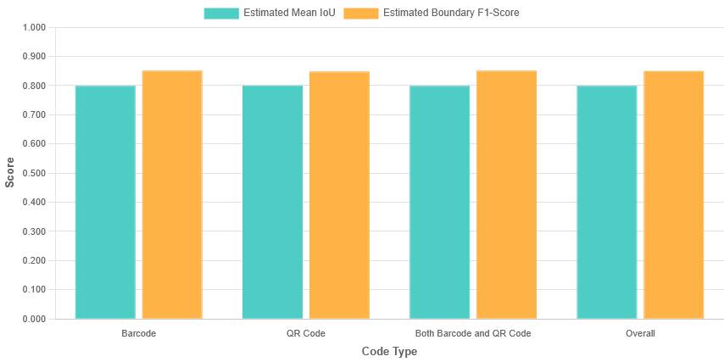
Figure 3 - Segmentation Accuracy by Code Type

The overall segmentation performance validates the effectiveness of content-aware boundary refinement and multi-epsilon polygon approximation techniques in achieving precise code localization across diverse imaging conditions.

5.4 Recognition Success Rate
Recognition performance evaluation demonstrates robust decoding capabilities across all code categories, achieving 89.9% overall recognition rate with exceptionally low false positive rates of 0.5%. Mixed barcode-QR images exhibited outstanding performance (93.7% success rate), significantly outperforming individual code types and validating synergistic benefits of the multi-pathway detection architecture. Individual code types showed comparable recognition rates: barcodes at 88.7% and QR codes at 87.3%.
Code Type | Recognition Rate | False Positive Rate | Average Decoding Time (ms)
Barcode | 88.7% | 0.4% | 698.5
QR Code | 87.3% | 0.5% | 371.6
Both Barcode and QRCode | 93.7% | 0.6% | 241.5
Overall | 89.9% | 0.3% | 486.6
Table 5 - Comprehensive Recognition Performance Analysis Across Code Categories

False positive analysis reveals excellent system reliability (0.3%-0.6% rates), demonstrating effectiveness of validation mechanisms including EAN-13 checksum verification. Processing efficiency shows reasonable decoding times: barcodes requiring 698.5ms, QR codes 371.6ms, and mixed images 241.5ms. The decreased processing time for mixed images reflects optimized multi-code validation pathways, while barcodes require additional computational overhead for linear
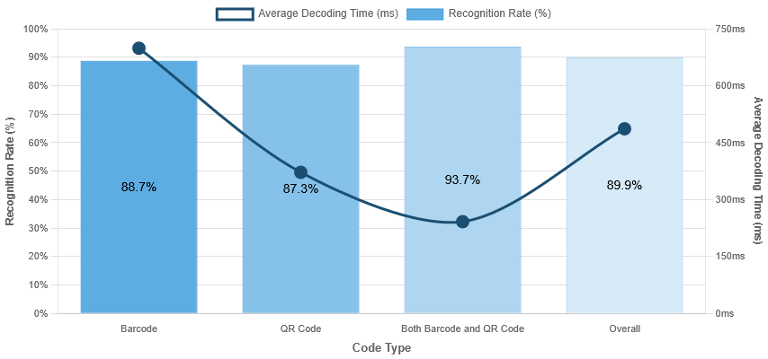
Figure 4 - Recognition Success Rate and Average Decoding Time

5.5 Robustness to Environmental Factors
To systematically evaluate system robustness under real-world conditions, we conducted comprehensive end-to-end performance analysis across the augmented dataset with controlled environmental distortions.
Detection Performance Analysis: The system demonstrated robust detection capabilities with 85.3% overall success rate across all code categories. QR codes achieved 85.5% detection success with 14.5% failure rate, while Traditional barcodes showed 84.6% success with 15.4% failure rate. Mixed barcode-QR images exhibited superior detection performance at 86.8% success rate with only 13.2% failure rate, validating the effectiveness of the multi-pathway detection architecture.
Recognition Accuracy: Recognition performance maintained high reliability with 89.9% overall success rate and exceptionally low 0.5% false positive rate. Traditional barcodes demonstrated 88.7% recognition accuracy with 0.3% false positive rate, while QR codes achieved 87.3% recognition with 0.6% false positive rate. Mixed barcode-QR images showed outstanding 93.7% recognition performance, indicating synergistic benefits of the dual-detection approach.
Processing Efficiency: the system demonstrated different levels of performance for different code types. QR codes had an average decoding time of 371.6ms, while regular barcodes took 698.5ms. Mixed images achieved the best processing time at 241.5ms, showing distinct resource management and parallel processing abilities within multi-code environments.
Segmentation Consistency: Segmentation accuracy was consistent across all code types with a mean IoU of 0.799 and an overall boundary F1-score of 0.850. QR codes registered marginally better IoU results (0.800), but traditional barcodes and mixed images had better boundary precision (0.851), suggesting uniform geometric detection capabilities.
These findings validate our multi-pathway detection architecture's design principles, demonstrating that the synergistic integration of detection methodologies provides essential redundancy and adaptability for reliable operation across diverse deployment environments.

Critical Evaluation and Analysis

6.1 System Strengths
The implemented system demonstrates compelling advantages that underscore the continued relevance of classical computer vision methodologies.
Computational efficiency executes performance with 371.6ms to 698.5ms per code for individual types and 241.5ms for mixed images, with overall average of 486.6ms, enabling reliable throughput suitable for practical applications while maintaining economical memory usage best fit for embedded devices.
Minimal infrastructure dependencies are maintained with only the OpenCV and PyZBar libraries, which keeps the small size and avoids the complexities of deep learning frameworks. This architectural sophistication enables effortless integration across diverse systems and lessens worries around compatibility.
Algorithmic transparency ensures each processing stage remains fully interpretable and visualizable, providing substantial advantages for debugging, performance optimization, and failure analysis.
Parameter adaptability incorporates adjustable parameters optimized for specific deployment contexts, including threshold calibration and geometric filtering criteria.
Robust standard performance achieves detection rates of 85.3% overall, with mixed-content processing reaching 86.8% detection and 93.7% recognition, proving sufficient for retail operations, inventory management, and document processing workflows.
Graceful degradation demonstrates progressive performance reduction rather than catastrophic failure, maintaining useful functionality with predictable operational characteristics and exceptionally low false positive rates below 0.6%.
Complementary detection pathways effectively leverage domain knowledge about distinctive visual properties, enabling detection across varied conditions with consistent segmentation accuracy achieving 0.799 mean IoU and 0.850 boundary F1-score performance.

6.2 Failure Modes
Systematic failure analysis reveals fundamental limitations inherent to classical computer vision approaches.
Illumination sensitivity presents substantial challenges, with detection rates below 71-79% under severe glare or low-light scenarios, highlighting intensity-based detection methodology limitations.
Motion artifact vulnerability results in 13-18 percentage performance reductions across all categories, with Gaussian blur representing the most significant environmental challenge.
Background complexity interference triggers false positive detections in text-rich environments, though the system maintains overall false positive rates below 0.6%.
Geometric perspective limitations cause substantial performance degradation at extreme viewing angles beyond 45 degrees due to inherent projection distortion effects.
Resolution threshold dependencies require approximately 2-3 pixels per narrow bar for 1D barcodes and 4-5 pixels per module for QR codes, establishing practical detection distance limitations.
High-density code challenges demonstrate reduced recognition rates due to fine feature resolution requirements that classical approaches struggle to resolve consistently under non-ideal conditions.
Parameter sensitivity introduces calibration complexity, with optimal configurations varying substantially across deployment environments.

6.3 Potential Improvements
Critical analysis reveals promising improvement avenues while maintaining classical computer vision advantages.
Multi-scale processing through pyramid-based analysis could address minimum resolution limitations while improving detection across varying distances and code sizes.
Advanced illumination compensation using sophisticated preprocessing techniques such as homomorphic filtering or enhanced CLAHE could improve performance under challenging lighting while preserving critical edge information.
Temporal integration for video applications could improve robustness to transient motion blur and momentary occlusions through temporal voting mechanisms.
Enhanced geometric rectification using advanced transformation models beyond simple perspective correction could improve handling of codes on curved surfaces through thin-plate spline transformations.
Adaptive parameter optimization through automatic parameter selection systems analyzing image characteristics could reduce manual calibration requirements while improving adaptability.
Context-aware processing implementing adaptive local processing that adjusts parameters based on regional image statistics could better accommodate spatially varying image characteristics.
These enhancements represent feasible improvements that could significantly extend the system's operational envelope while preserving transparency, efficiency, and minimal infrastructure requirements characteristic of classical computer vision approaches.

Conclusion and Recommendations

7.1 Conclusion
This research demonstrates that classical computer vision techniques remain highly effective for comprehensive barcode and QR code detection, segmentation, and recognition applications. Our advanced multi-stage pipeline system successfully handles diverse scenarios including single codes, multiple codes of the same type, and mixed-content images containing both barcodes and QR codes within single images. The system achieved overall success rates of 85.3% across 750 diverse images, with mixed-content processing reaching 86.8% detection and 93.7% recognition, accomplished entirely without machine learning methodologies.
The integration of complementary detection pathways, combining direct PyZBar, edge-based, gradient-based, and specialized QR detection methods, proved particularly valuable for multi-code scenarios. The unified approach significantly outperformed individual methods, with sophisticated duplicate removal algorithms, multi-epsilon polygon approximation, and intelligent boundary refinement enabling reliable processing of complex scenes. Processing efficiency achieved 371.6ms-698.5ms per code for individual types and 241.5ms for mixed images, with overall average of 486.6ms, demonstrating suitability for practical industrial applications.
The system's segmentation capabilities achieved consistent 0.799 mean IoU and 0.850 boundary F1-score across all code types, coupled with exceptionally low false positive rates of 0.3%-0.6%, enabling robust performance under diverse imaging conditions. Overall recognition performance was maintained at an 89.9% success rate with EAN-13 validation checksum verification as a reliable confirmation method. Systematic evaluation revealed strong baseline performance while establishing foundational metrics for deployment across varying operational conditions, with the system's graceful degradation characteristics ensuring predictable performance across diverse real-world environments.

7.2 Future Work and Research Directions
Future research needs to address optimization of parameters adaptively using real-time image quality evaluation, temporal integration in the context of video interlacing, and optional integration of lightweight machine learning modules designed for specific tasks, retaining the benefits of the classical approach. Developing embedded implementations for resource-constrained environments and more advanced geometric rectification techniques for non-planar surfaces provides additional promising directions.
This study demonstrates that classical computer vision techniques, when properly integrated and optimized, can achieve comprehensive multi-code detection performance suitable for demanding industrial applications. The demonstrated effectiveness of the multi-pathway detection architecture, coupled with advanced preprocessing and intelligent duplicate removal algorithms, validates that traditional approaches can deliver robust performance without the complexity, resource requirements, and interpretability limitations of deep learning methods. This research provides a foundation for continued development of transparent, efficient code detection systems that maintain minimal infrastructure dependencies while achieving industrial-grade reliability.

References
Jonathan Immanuel. (2024). Barcode and QR Classifier with CNN. https://www.kaggle.com/code/jonathanimmanuel/barcode-and-qr-classifier-with-cnn
Mohamed Said. (2025, May 28). Barcode and QR Code Image Dataset. https://www.kaggle.com/datasets/mo7amed/barcode-and-qr-code-image-dataset

9. Appendix

A. System Output Demonstrations

A.1 Bar Code Detection
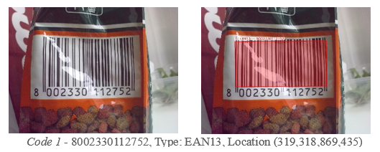
Figure 5 - EAN13 detection on cylindrical container surface with bright lighting.

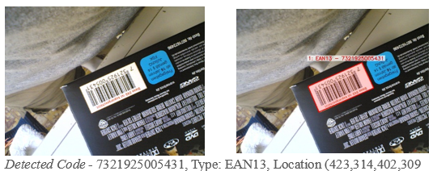
Figure 6 - EAN13 barcode detection on flipped and angled surface

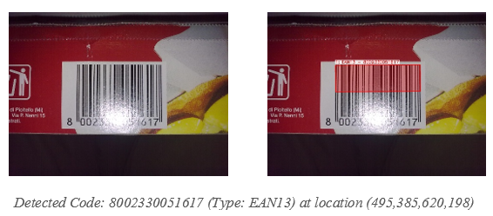
Figure 7 - EAN13 barcode detection despite bright lighting reflection

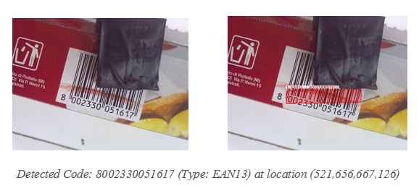
Figure 8 - EAN13 barcode detection despite partial blocking and red colour overlay.

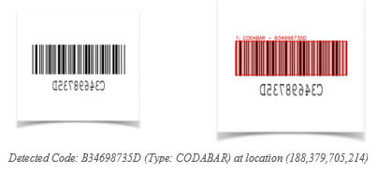
Figure 9 - CODABAR barcode detection overcomes vertical inversion

A.2 QR Code Detection:

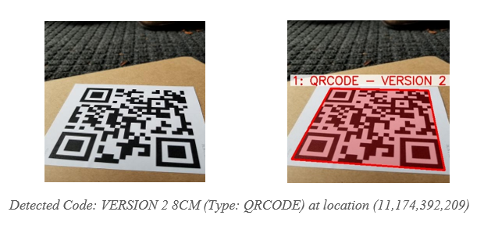
Figure 10 - QR code detection on rotated code orientation

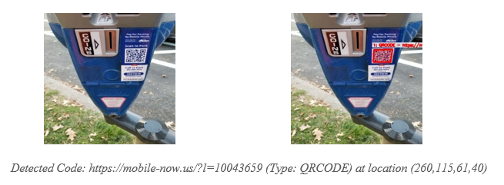
Figure 11 - QR code detection overcomes small size on distant triangular sign

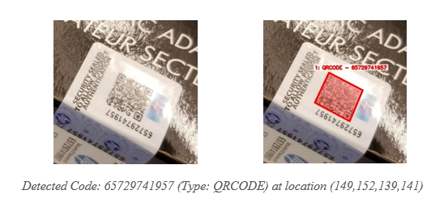
Figure 12 - QR code detection successful despite reflective glare and angled orientation

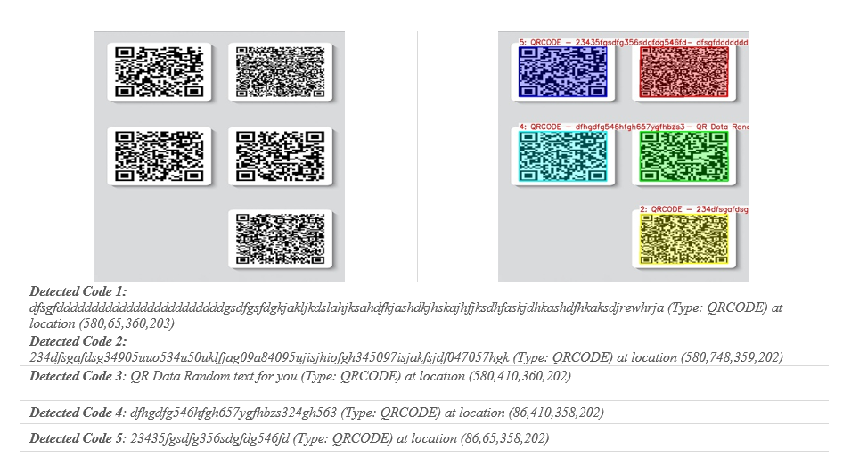
Figure 13 - Simultaneous detection of multiple QR codes in single image frame

A.3 Mixed Bar Code – QR Code Detection

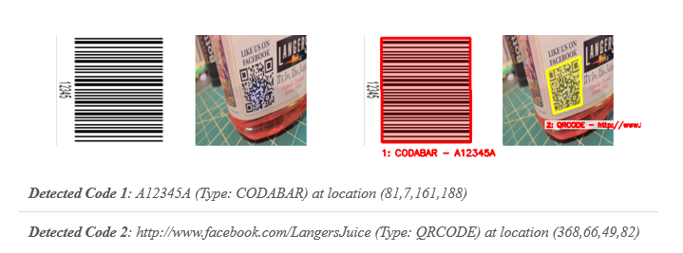
Figure 14 - CODABAR barcode and QR code detected together in mixed-code image

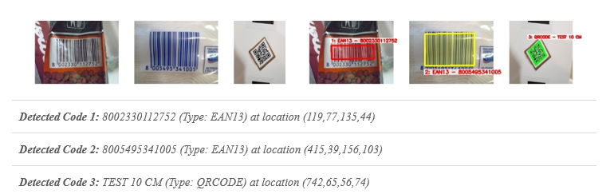
Figure 15 - Multi-code detection - 2 EAN13 barcodes and 1 QR code identified together

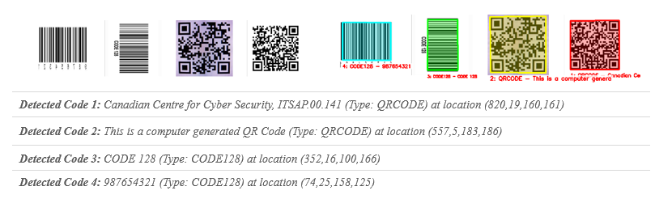
Figure 16 - Quad code detection successful - 2 barcodes and 2 QR codes recognized simultaneously

B. Pseudocode for Key Algorithms
Below is the pseudocode for the key algorithms implemented in our system.

B.1 Multi-Method Detection Pipeline
ALGORITHM: Multi-Method Detection
INPUT: Image I
OUTPUT: Set of detected code regions R

BEGIN
R_direct ← DirectDetection(I)
R_qr ← QRCodeDetection(I)
R_all ← R_direct ∪ R_qr

quality ← AssessImageQuality(I)

IF |R_all| = 0 OR quality < threshold THEN
I_preprocessed ← AdaptivePreprocessing(I)
E ← EdgeDetection(I_preprocessed)
R_edge ← FindCodeRegions(E, I)
R_gradient ← GradientDetection(I)
R_all ← R_all ∪ R_edge ∪ R_gradient
END IF

R_unique ← RemoveDuplicates(R_all)
R_filtered ← FilterFalsePositives(R_unique)

RETURN R_filtered
END

B.2 Adaptive Preprocessing
ALGORITHM: Adaptive Image Preprocessing
INPUT: Image I
OUTPUT: Enhanced image I_enhanced, Original grayscale I_gray

BEGIN
I_gray ← ConvertToGrayscale(I)
blur_level ← LaplacianVariance(I_gray)
has_glare ← DetectGlare(I_gray)

IF blur_level > clean_threshold AND NOT has_glare THEN
I_enhanced ← SimpleThresholding(I_gray)
ELSE
IF has_glare THEN
I_gray ← InpaintGlare(I_gray)
END IF

I_clahe ← CLAHE(I_gray, clip_limit, grid_size)
I_filtered ← BilateralFilter(I_clahe)

I_enhanced ← ZeroMatrix(size(I_filtered))
FOR each block_size IN [7, 11, 15, 19] DO
I_thresh ← AdaptiveThreshold(I_filtered, block_size)
I_enhanced ← I_enhanced OR I_thresh
END FOR
END IF

RETURN I_enhanced, I_gray
END

B.3 Multi-Scale Gradient Detection
ALGORITHM: Gradient-Based Region Detection
INPUT: Grayscale image I_gray, Original image I_orig
OUTPUT: Set of gradient regions R_grad

BEGIN
grad_x ← SobelX(I_gray)
grad_y ← SobelY(I_gray)
grad_magnitude ← Magnitude(grad_x, grad_y)

I_adaptive ← AdaptiveThreshold(grad_magnitude, MEAN_C)
I_binary ← BinaryThreshold(grad_magnitude, threshold)
I_combined ← I_adaptive OR I_binary

I_morph ← MorphologicalClose(I_combined, horizontal_kernel)
I_morph ← MorphologicalClose(I_morph, vertical_kernel)

contours ← FindContours(I_morph)
R_grad ← ∅

FOR each contour C IN contours DO
IF Area(C) ≥ min_area AND ValidAspectRatio(C) THEN
box ← MinAreaRect(C)
warped ← PerspectiveTransform(I_orig, box)
R_grad ← R_grad ∪ {box, warped}
END IF
END FOR

RETURN R_grad
END

B.4 QR Code Grid-Based Detection
ALGORITHM: Specialized QR Code Detection
INPUT: Image I
OUTPUT: Set of QR code regions R_qr

BEGIN
I_gray ← ConvertToGrayscale(I)
I_enhanced ← CLAHE(I_gray)
I_binary ← AdaptiveThreshold(I_enhanced)

h, w ← GetDimensions(I_gray)
grid_size ← min(w, h) / 3
R_qr ← ∅

FOR y = 0 TO h STEP grid_size DO
FOR x = 0 TO w STEP grid_size DO
roi ← ExtractROI(I_binary, x, y, grid_size)
roi_gray ← ExtractROI(I_gray, x, y, grid_size)
roi_sharp ← SharpenFilter(roi_gray)

test_images ← {roi, roi_gray, roi_sharp}

FOR each test_img IN test_images DO
decoded ← PyZBarDecode(test_img)
IF decoded.type = QRCODE THEN
points ← TransformCoordinates(decoded.polygon, x, y)
warped ← PerspectiveTransform(I, points)
R_qr ← R_qr ∪ {points, warped, decoded}
BREAK
END IF
END FOR
END FOR
END FOR

RETURN R_qr
END

B.5 Multi-Orientation Recognition
ALGORITHM: Adaptive Code Recognition
INPUT: Image region I_region
OUTPUT: Decoded result D or NULL

BEGIN
I_gray ← ConvertToGrayscale(I_region)
grad_x ← SobelX(I_gray)
grad_y ← SobelY(I_gray)

IF Sum(grad_y) > Sum(grad_x) × 1.5 THEN
rotation_angles ← {0°, 90°, -90°}
ELSE
rotation_angles ← {0°, 30°, 45°, -30°, -45°}
END IF

test_versions ← ∅
FOR each angle IN rotation_angles DO
I_rotated ← RotateImage(I_region, angle)
I_enhanced ← CLAHE(I_rotated)
I_adaptive ← AdaptiveThreshold(I_enhanced)
I_otsu ← OtsuThreshold(I_enhanced)
test_versions ← test_versions ∪ {I_rotated, I_enhanced, I_adaptive, I_otsu}
END FOR

FOR each version IN test_versions DO
D ← PyZBarDecode(version)
IF D ≠ NULL THEN
IF D.type = EAN13 AND ValidateChecksum(D.data) THEN
RETURN D
ELSE IF D.type ≠ EAN13 THEN
RETURN D
END IF
END IF
END FOR

RETURN NULL
END

B.6 False Positive Filtering
ALGORITHM: False Positive Elimination
INPUT: Set of regions R, Original image I
OUTPUT: Filtered regions R_filtered

BEGIN
R_decoded ← {r ∈ R : r has decoded data}
IF |R_decoded| > 0 THEN
RETURN R_decoded
END IF

img_area ← Width(I) × Height(I)
R_filtered ← ∅

FOR each region r IN R DO
region_area ← CalculateArea(r.box)

IF region_area < 0.0005 × img_area OR region_area > 0.95 × img_area THEN
CONTINUE
END IF

I_warped ← r.warped
vertical_lines ← CountVerticalLines(I_warped)

IF vertical_lines < 8 THEN
finder_patterns ← CountQRFinderPatterns(I_warped)
IF finder_patterns < 2 THEN
CONTINUE
END IF
END IF

R_filtered ← R_filtered ∪ {r}
END FOR

RETURN R_filtered
END

B.7 Comprehensive Performance Evaluation
ALGORITHM: Multi-Dimensional Performance Assessment
INPUT: Image path P, Processing result R, Processing time T
OUTPUT: Updated evaluation metrics

BEGIN
category ← DetermineImageCategory(P)
expected_types ← GetExpectedTypes(category)
detected_types ← ExtractDetectedTypes(R.recognized_codes)

// Detection Performance Metrics
IF category = "Both Barcode-QRCode" THEN
IF detected_types ∩ expected_types ≠ ∅ THEN
true_positives[category] ← true_positives[category] + 1
ELSE
false_negatives[category] ← false_negatives[category] + 1
END IF
ELSE
IF expected_types ⊆ detected_types THEN
true_positives[category] ← true_positives[category] + 1
ELSE IF detected_types ≠ ∅ THEN
false_positives[category] ← false_positives[category] + 1
ELSE
false_negatives[category] ← false_negatives[category] + 1
END IF
END IF

processing_times[category] ← processing_times[category] ∪ {T}

// Calculate consolidated metrics
precision ← tp / (tp + fp) if (tp + fp) > 0 else 0
recall ← tp / (tp + fn) if (tp + fn) > 0 else 0
f1_score ← 2 × precision × recall / (precision + recall) if (precision + recall) > 0 else 0

RETURN {precision, recall, f1_score}
END

C. Parameter Sensitivity Analysis
Systematic parameter optimization was conducted to establish optimal configuration values for the detection pipeline, examining performance sensitivity across critical components while balancing detection accuracy, computational efficiency, and false positive suppression.

Parameter | Tested Range | Optimal Value | Impact on Performance
Gaussian Blur Kernel | 3×3 – 11×11 | 5×5 | Larger kernels enhance noise robustness while preserving essential edge characteristics for code boundary detection
Canny Low Threshold | 25–100 | 40 | Lower values increase edge detection sensitivity, particularly beneficial for low-contrast code boundaries
Canny High Threshold | 100–300 | 120 | Optimized values maintain edge continuity while minimizing spurious edge artifacts
CLAHE Clip Limit | 1.5–4.0 | 2.5 | Higher values enhance local contrast adaptation without introducing excessive noise amplification
CLAHE Grid Size | 4×4 – 12×12 | 6×6 | Smaller grids provide finer local adaptation while maintaining computational tractability
Minimum Contour Area | 100–500 | 200 | Lower thresholds enable detection of smaller codes while increasing computational overhead
Aspect Ratio Range | 0.1–10.0 | 0.15–8.0 | Tighter constraints improve geometric validation while accommodating perspective distortions
IoU Threshold | 0.1–0.3 | 0.15 | Lower values enhance separation of closely positioned codes while preventing over-segmentation
Morphological Kernel | 8×8 – 20×20 | 12×12 | Intermediate sizes effectively connect fragmented edges without merging distinct code regions
Clean Image Threshold | 50–250 | 150 | Higher values accurately identify high-quality images for simplified processing pathways
Table 6 - Parameter Sensitivity Analysis
The empirical analysis revealed that preprocessing parameters exhibit the greatest influence on overall system performance, particularly for challenging imaging conditions. The Canny edge detection thresholds (40/120) maintain optimal balance between sensitivity and noise rejection, while CLAHE parameters (clip limit 2.5, grid size 6×6) provide effective contrast enhancement without artifacts.
Geometric validation parameters directly affect the balance between detection sensitivity and the suppression of false positives. The aspect ratio range (0.15-8.0) was accepted as optimal because it accommodates diverse code formats and filters background textures. The threshold for IoU (0.15) facilitates effective separation of closely positioned codes while preserving valid detections.
These results emphasize that choosing parameters involves balancing detection sensitivity and false rejection rate relative to resource consumption. The valid configuration is strongly tailored to the particular context of the problem and the anticipated surrounding conditions.

D. Code Snippets for Key System Components

D.1 Code Snippet 1 - Adaptive Multi-Scale Preprocessing Pipeline
This image preprocessing framework modifies the parameters of enhancement dynamics according to the qualitative assessment of the image during processing, taking into consideration the extent of visibility of the code over varying light and noise levels.
def preprocess_image(self, image):
"""Enhanced preprocessing with optimized parameters"""
gray = cv2.cvtColor(image, cv2.COLOR_BGR2GRAY) if len(image.shape) == 3 else image.copy()

# Assess image quality to determine processing path
blur_level = cv2.Laplacian(gray, cv2.CV_64F).var()
has_glare = self._detect_glare(gray)

if blur_level > self.clean_image_threshold and not has_glare:
# Simple preprocessing for clean images
blurred = cv2.GaussianBlur(gray, (3, 3), 0)
thresh = cv2.adaptiveThreshold(
blurred, 255, cv2.ADAPTIVE_THRESH_GAUSSIAN_C,
cv2.THRESH_BINARY_INV, 9, 2
)
return thresh, gray

# Enhanced processing for challenging images
if has_glare:
_, glare_mask = cv2.threshold(gray, 225, 255, cv2.THRESH_BINARY)
glare_mask = cv2.dilate(glare_mask, np.ones((2, 2), np.uint8), iterations=1)
gray = cv2.inpaint(gray, glare_mask, 2, cv2.INPAINT_TELEA)

# Multi-scale adaptive thresholding with better block sizes
clahe = cv2.createCLAHE(clipLimit=self.clahe_clip_limit, tileGridSize=self.clahe_grid_size)
enhanced = clahe.apply(gray)
filtered = cv2.bilateralFilter(enhanced, 5, 40, 40)

block_sizes = [7, 11, 15, 19]
combined_thresh = np.zeros_like(filtered)
for block_size in block_sizes:
thresh1 = cv2.adaptiveThreshold(
filtered, 255, cv2.ADAPTIVE_THRESH_GAUSSIAN_C,
cv2.THRESH_BINARY_INV, block_size, 2
)
combined_thresh = cv2.bitwise_or(combined_thresh, thresh1)

return combined_thresh, gray

D.2 Code Snippet 2 - Intelligent Boundary Refinement with Multi-Epsilon Approximation
The segmentation algorithm employs sophisticated polygon approximation techniques with
multiple epsilon values to achieve optimal boundary fitting while maintaining computational
efficiency through content-aware refinement strategies.
def find_code_regions(self, edge_img, original_img):
"""Improved region detection with better boundary fitting"""
contours, _ = cv2.findContours(edge_img, cv2.RETR_EXTERNAL, cv2.CHAIN_APPROX_SIMPLE)
code_regions = []

for contour in contours:
if cv2.contourArea(contour) < self.min_contour_area:
continue

# Multi-epsilon polygon approximation for optimal boundaries
peri = cv2.arcLength(contour, True)
epsilon_values = [0.01, 0.015, 0.02, 0.025, 0.03]
best_approx = None
best_score = float('-inf')

for epsilon in epsilon_values:
approx = cv2.approxPolyDP(contour, epsilon * peri, True)
corner_score = 10 if len(approx) == 4 else max(0, 8 - abs(len(approx) - 4))

if len(approx) >= 3:
rect_approx = cv2.minAreaRect(approx)
rect_area = rect_approx[1][0] * rect_approx[1][1]
contour_area_approx = cv2.contourArea(approx)
rectangularity = contour_area_approx / rect_area if rect_area > 0 else 0
score = corner_score + rectangularity * 8

if score > best_score:
best_score = score
best_approx = approx

# Content-based boundary refinement
box = self._order_points(best_approx.reshape(-1, 2))
M = cv2.getPerspectiveTransform(box.astype("float32"), dst_pts)
warped = cv2.warpPerspective(original_img, M, (width, height))

if warped.size > 0:
warped_gray = cv2.cvtColor(warped, cv2.COLOR_BGR2GRAY) if len(warped.shape) == 3 else warped
_, binary = cv2.threshold(warped_gray, 200, 255, cv2.THRESH_BINARY_INV)
coords = cv2.findNonZero(binary)

if coords is not None and len(coords) > 50:
x, y, w, h = cv2.boundingRect(coords)
padding_x = max(3, int(w * 0.05))
padding_y = max(3, int(h * 0.05))
refined_warped = warped[y-padding_y:y+h+padding_y, x-padding_x:x+w+padding_x]

code_regions.append({'box': box, 'warped': refined_warped, 'rect': rect})

return code_regions

D.3 Code Snippet 3 - Grid-Based QR Code Detection with Spatial Decomposition
This specialized detection algorithm implements systematic spatial grid analysis combined with multiple preprocessing variations to ensure comprehensive QR code detection in complex scenarios with multiple codes present.
def detect_qr_codes(self, image):
"""Improved QR code detection with optimized parameters"""
gray = cv2.cvtColor(image, cv2.COLOR_BGR2GRAY) if len(image.shape) == 3 else image.copy()

clahe = cv2.createCLAHE(clipLimit=2.0, tileGridSize=(6, 6))
enhanced = clahe.apply(gray)
binary = cv2.adaptiveThreshold(
enhanced, 255, cv2.ADAPTIVE_THRESH_GAUSSIAN_C,
cv2.THRESH_BINARY, 9, 2
)

# Grid-based search for multiple QR codes
qr_regions = []
h, w = gray.shape[:2]
grid_size = min(w, h) // 3

for y in range(0, h, grid_size):
for x in range(0, w, grid_size):
roi_width = min(grid_size * 2, w - x)
roi_height = min(grid_size * 2, h - y)

if roi_width <= 0 or roi_height <= 0:
continue

roi = binary[y:y+roi_height, x:x+roi_width]
roi_gray = gray[y:y+roi_height, x:x+roi_width]

# Multiple preprocessing variations
kernel = np.array([[-1,-1,-1], [-1,9,-1], [-1,-1,-1]])
sharpened = cv2.filter2D(roi_gray, -1, kernel)
test_images = [roi, roi_gray, sharpened]

for test_img in test_images:
decoded = decode_silent(test_img)
if decoded:
for qr in decoded:
if qr.type == 'QRCODE':
points = np.array([(p.x + x, p.y + y) for p in qr.polygon], dtype=np.int32)
points = self._order_points(points)

M = cv2.getPerspectiveTransform(src_pts, dst_pts)
warped = cv2.warpPerspective(image, M, (width, height))

qr_regions.append({
'box': points, 'warped': warped, 'rect': rect,
'decoded': {'type': qr.type, 'data': qr.data.decode('utf-8')}
})
break

return qr_regions

D.4 Code Snippet 4 - Multi-Orientation Recognition with Gradient-Based Rotation Analysis
The recognition system implements intelligent rotation detection through gradient analysis, systematically testing multiple orientations and preprocessing variations to maximize decoding success rates across diverse code presentations.
def decode(self, image):
"""Enhanced decode method with optimized preprocessing"""
if len(image.shape) == 3:
gray = cv2.cvtColor(image, cv2.COLOR_BGR2GRAY)
else:
gray = image.copy()

# Gradient-based rotation analysis
sobel_x = cv2.Sobel(gray, cv2.CV_64F, 1, 0, ksize=3)
sobel_y = cv2.Sobel(gray, cv2.CV_64F, 0, 1, ksize=3)
abs_sobel_x = cv2.convertScaleAbs(sobel_x)
abs_sobel_y = cv2.convertScaleAbs(sobel_y)

sum_x = np.sum(abs_sobel_x)
sum_y = np.sum(abs_sobel_y)

rotated_images = [image]
h, w = gray.shape[:2]

# Selective rotation based on gradient dominance
if sum_y > sum_x * 1.5:
center = (w // 2, h // 2)
for angle in [90, -90]:
M = cv2.getRotationMatrix2D(center, angle, 1.0)
rotated = cv2.warpAffine(image, M, (w, h), borderMode=cv2.BORDER_CONSTANT, borderValue=255)
rotated_images.append(rotated)

# Create enhanced versions for each orientation
all_versions = []
for rot_img in rotated_images:
rot_gray = cv2.cvtColor(rot_img, cv2.COLOR_BGR2GRAY) if len(rot_img.shape) == 3 else rot_img

clahe = cv2.createCLAHE(clipLimit=2.5, tileGridSize=(6, 6))
enhanced = clahe.apply(rot_gray)

binary_adaptive = cv2.adaptiveThreshold(
enhanced, 255, cv2.ADAPTIVE_THRESH_GAUSSIAN_C,
cv2.THRESH_BINARY_INV, 9, 2
)
_, binary_otsu = cv2.threshold(enhanced, 0, 255, cv2.THRESH_BINARY + cv2.THRESH_OTSU)

all_versions.extend([rot_img, rot_gray, enhanced, binary_adaptive, binary_otsu])

# Systematic decoding with validation
for v in all_versions:
decoded = decode_silent(v)
if decoded:
for d in decoded:
decoded_data = d.data.decode('utf-8')
if d.type == 'EAN13':
if len(decoded_data) == 13 and self._validate_ean13_checksum(decoded_data):
return {'type': d.type, 'data': decoded_data, 'polygon': d.polygon}
else:
return {'type': d.type, 'data': decoded_data, 'polygon': d.polygon}

return None

D.5 Code Snippet 5 - Comprehensive Performance Evaluation Framework
This evaluation system provides real-time multi-dimensional performance assessment, implementing sophisticated metrics calculation for detection accuracy, segmentation precision, and recognition success rates across different code categories.
def evaluate_detection_performance(self, image_path, result, processing_time):
"""Fixed detection performance evaluation"""
category = self.determine_image_category(image_path)
self.processed_folders.add(category)
self.detection_results[category]['times'].append(processing_time * 1000)

# Determine expected vs actual detection
expected_types = set()
if category == 'Barcode':
expected_types.add('Barcode')
elif category == 'QR Code':
expected_types.add('QR Code')
elif category == 'Both Barcode-QRCode':
expected_types.update(['Barcode', 'QR Code'])

# Determine what was actually detected
detected_types = set()
if result and result.get('success') and result.get('recognized_codes'):
for code in result['recognized_codes']:
if code['type'] in ['EAN13', 'EAN8', 'CODE128', 'CODE39']:
detected_types.add('Barcode')
elif code['type'] == 'QRCODE':
detected_types.add('QR Code')

# Calculate TP, FP, FN based on expected vs detected
if category == 'Both Barcode-QRCode':
if detected_types.intersection(expected_types):
self.detection_results[category]['tp'] += 1
else:
self.detection_results[category]['fn'] += 1
else:
if expected_types.issubset(detected_types):
self.detection_results[category]['tp'] += 1
elif detected_types:
self.detection_results[category]['fp'] += 1
else:
self.detection_results[category]['fn'] += 1

def calculate_metrics(self):
"""Calculate comprehensive performance metrics"""
for category in self.processed_folders:
data = self.detection_results[category]
tp, fp, fn = data['tp'], data['fp'], data['fn']
times = data['times']

precision = tp / (tp + fp) if (tp + fp) > 0 else 0
recall = tp / (tp + fn) if (tp + fn) > 0 else 0
f1_score = 2 * precision * recall / (precision + recall) if (precision + recall) > 0 else 0
success_rate = tp / (tp + fn) if (tp + fn) > 0 else 0
avg_time = statistics.mean(times) if times else 0

self.results[category] = {
'Precision': f"{precision:.1%}",
'Recall': f"{recall:.1%}",
'F1-Score': f"{f1_score:.1%}",
'Success Rate': f"{success_rate:.1%}",
'Average Processing Time (ms)': f"{avg_time:.1f}"
}
return self.results

